Cleveland State University
Office of Institutional Research & Analysis

Policy & Management Procedures Manual



Version Date: April 29, 2009

© Cleveland State University 2009

Table of Contents

Introduction 3
Mission Statement, Vision, and Values 3
Department Goals and Objectives 4
Reporting 7
Project Requests and Workflow 8
Quality Assurance 11
Confidentiality and Data Security 12
University and Department Policies Regarding Employees 13
Review and Update of the Policy & Management Procedures Manual 20
Appendix 1. Family Educational Right to Privacy Act (FERPA) 21
Appendix 2. Information Request Template 22
Appendix 3. IRAA Project Documentation Template 26
Appendix 4. Association of Institutional Research (AIR) Code of Ethics 27

Introduction

This Policy & Management Procedures Manual is provided to employees in the Cleveland State University Office of Institutional Research & Analysis (IRAA) for use as a reference and general guide. Should there be any discrepancies between the contents of this Manual and collective bargaining agreements covering employees represented by a union, the terms of the bargaining agreement will supersede content in the Manual.

The Office of Institutional Research & Analysis at Cleveland State plays a critical role in collecting, organizing, analyzing, reporting, and maintaining institutional data. The Office serves as a resource for both internal and external constituents and seeks to support the mission of Cleveland State University.

Mission Statement, Vision, and Values

Cleveland State University Mission Statement

Our mission is to encourage excellence, diversity, and engaged learning by providing a contemporary and accessible education in the arts, sciences, humanities and professions, and by conducting research, scholarship, and creative activity across these branches of knowledge. We endeavor to serve and engage the public and prepare our students to lead productive, responsible and satisfying lives in the region and global society.

Cleveland State University Vision Statement

We will be recognized as a student-focused center of scholarly excellence that provides an accessible, engaged and exceptional education to all. We will be a place of opportunity for those who seek truth, strive toward excellence and seek a better life for themselves and for their fellow citizens. As a leader in innovative collaboration — both internally and externally — with business, industry, government, educational institutions and the community, the University will be a critical force in the region's economic development. We will be at the forefront of moral, ethical, social, artistic and economic leadership for the future and embrace the vitality that comes with risk. We will be the strongest public university in the region and be known for our scholarship and diversity in service to students and to our community.

Office of Institutional Research & Analysis Mission Statement and Values

Mission

The Office of Institutional Research & Analysis supports the mission of Cleveland State University by providing consistent, accurate and timely information to internal and external decision makers and stakeholders.

Specifically, the Office is responsible for:

- Compiling, organizing, maintaining, and analyzing data from internal and external sources
- Developing and maintaining comprehensive data and information systems
- Providing timely and value-added information to internal and external constituents for recurrent and ad hoc reporting purposes
- Conducting institutional research studies to support University planning and decision making
- Assisting the University in planning, assessment, information management, academic program review, self-study, and other initiatives as needed

Values

The Office is committed to:

- Encouraging diversity, mutual respect, and team work
- Maintaining integrity in all data and research-related activities
- Safeguarding sensitive data and protecting confidentiality
- Demonstrating accountability and excellence in office operations
- Adhering to the Association of Institutional Research (AIR) Code of Ethics

Department Goals and Objectives

Information Integrity

The validity and reliability of information produced by an institutional research office is essential and often determines the success or failure of a project. Information integrity, and the capacity to maintain it, can provide a sustainable competitive advantage. Integrity is often the key that differentiates useful information from that which will not be utilized.
The Office will:

- Ensure continued improvement in quality and usability of IRAA analyses
and reports
- Create and maintain IRAA data tables and documentation that meet the needs for both University reporting and longitudinal studies
- Employ best practice methods to achieve the highest level of quality and organizational excellence through individual and team efforts
- Provide timely, accurate, and consistent services to key internal and external constituents
- Implement cost-effective and value-added operational processes

Information Sharing Environment

Our office is committed to promoting an environment of information sharing in which the personnel work together in a spirit of cooperation and collaboration. Such spirit cultivates a higher level of quality in providing value-added transformation from “data → information” and from “information → knowledge” without compromising integrity and confidentiality requirements. We will:

- Proactively implement changes to enhance IR data collection procedures and practices to meet the changing needs of the campus community
- Serve as a clearinghouse for university statistical information
- Consult regularly with faculty and staff regarding research design, data collection, analysis, interpretation, and reporting
- Establish and steward an open communication practice especially with data custodians and report users

Human Capital

To ensure information integrity and to facilitate an information sharing environment, it is critical to develop and retain personnel who are competent, knowledgeable, diverse, and teamwork-oriented with both technical and analytical skill sets that foster the highest level of performance and accountability. In accordance with the University employee manual published by the Department of Human Resources & Labor Relations, IRAA will:

- Ensure retention of highly qualified staff through continued professional development
- Sustain, promote and develop training and mentoring opportunities
- Encourage self-directed cross-functional work teams
- Encourage staff to identify and initiate process improvements
- Pursuant to university guidelines, link incentives to performance
Office of Institutional Research & Analysis Organizational Chart

President

Provost and Senior
Vice President for Academic Affairs

Vice Provost for Planning, Assessment, and Information Resource Management

Director,
Institutional
Research & Analysis

Research Associate

System
Developer

Senior
Application Developer (2)

Assessment,
Learning Communities,
East & West Center
Off-Campus Operations

Administrative Coordinator

Administrative Assistant

Senior Report
Developer

System
Developer

Reporting

Federal/Regional/State

IRAA completes over 100 Federal, regional, and state reports each year (including both annual and semester-based reports). These reports are often considered “mandatory” and are subject to both internal and external audit reviews. The timeliness and the accuracy of these reports directly affect the University’s ability to serve its constituencies. Examples of these agencies and reports include:

- US Department of Education Integrated Postsecondary Education Data System (IPEDS) http://nces.ed.gov/IPEDS/
- National Science Foundation
- US Department of Labor, Defense, and Homeland Security
- Higher Learning Commission North Central Accreditation Agency (HLC/NCA)
- National Collegiate Athletic Association (NCAA)
- Council of Graduate Schools / Graduate Record Exam (CGS/GRE)
- Ohio Board of Regents (OBOR) Higher Education Information Systems (HEI) http://regents.ohio.gov/hei/index.php

Other External Organization Reports

External organizations are those with which the University has no contractual relationship; hence, IRAA has no contractual obligations to provide services and reports. However, responding to external requests often promotes the sharing of information between the University and the community it serves. In general, IRAA responds to external requests to the best of its ability. In some instances, the requesting agency will be asked to reimburse for the costs of producing the reports. Some examples of these agencies and reports include:

- Common Data Set (CDS)
- College and University Professional Association for Human Resources
(CUPA-HR)
- American Association of University Professors (AAUP)
- American College Testing (ACT)
- US News and World Report
- The Plain Dealer

Internal Recurrent and Ad Hoc Reports

Over the years, IRAA has developed a series of reports aimed at monitoring day-to-day University enrollment, providing trend analyses, and reminding the campus community of events and issues important to University reporting. These reports include daily enrollment updates, semester enrollment reports and tables, the annual Fact-Book/Book of Trends, and academic unit profiles, among others. Most recurring reports are available on the IRAA website, however, some require system login.

Ad hoc requests may come from anyone in the campus community. The ability to respond to ad hoc requests in a timely and accurate manner is crucial and has been a significant function of IRAA. The response often serves as a measurement by the campus community of IRAA’s customer service. The online request process is described below under the heading of “Internal Requests” and the Information Request form is available on the IRAA website.

Project Requests and Workflow

External Organizations

External requests are usually sent to the contact person on record (typically, the contact is the Director or the person who completed the report for the prior submission cycle). The Director will assign the request to the appropriate IRAA personnel for completion.

Internal Requests

Requests from University faculty and staff for data and analysis should be submitted using the web-based Information Request form. See Appendix 2 for the Information Request template. This form facilitates prioritization and tracking of all data requests made to the Office of Institutional Research and will help to ensure timely follow-up.

The Director will review the report request, contact the requestor for clarification (if necessary), and assign the project to one of the IRAA personnel based on expertise and current workload. The timeline and due date for the project will be determined together by the Director and the IRAA personnel, and the timeline and due date will be communicated to the requestor. Although everyone on the IRAA team will be copied on incoming requests, the Director will respond to the requestor and determine the project assignment.
Requests for Sensitive Data and Media Inquiries

Exercise caution in fielding inquiries from members of the media (e.g. television, radio, newspaper) If the information requested has already been publicly disseminated (e.g., finalized enrollment reports, Book of Trends data available on the IRAA web site), IRAA staff members are expected to fulfill the request in a professional and timely manner and notify the Director.

If the request is for data or information that has not been publicly released, or if the request entails sensitive data, IRAA personnel should refer the requestor to the Director. Please refrain from entering into discussions with media personnel or disseminating sensitive data to anyone outside of the IRAA office without the explicit permission of the Director.

The decisions regarding response to external requests, are guided by the Family Educational Rights and Privacy Act (FERPA) [also known as the Buckley Amendment, See Appendix 1 for the final rule from the Department of Education, 34 CFR Part 99].

Workflow and Prioritization

The Director is responsible for prioritizing projects and monitoring workflow. Workflow management and project prioritization are critical components in enhancing the institutional research process. Proper attention given to this processes ensures that the right people are engaged at the right point in time.
The ultimate goal is to streamline the workflow and improve overall effectiveness by minimizing misunderstandings and delays.

The director will manage the workflow and prioritization process in accordance with an employee’s expertise, capabilities, and workload and will provide training and mentoring when needed. In addition, prioritizing projects and monitoring of the workflow should be transparent. The Information Request form is designed to automatically populate a tracking database. The person who completes the project is expected to close out the request and document completion. In the case of recurrent reports and particularly for those that are not requested using the Information Request form (e.g., IPEDS, OBOR, US News & World Report), the Director or designee will complete an abbreviated version of the request form in order to capture the project description and timelines in the database. The database should serve as a source for internal auditing purposes and for summarizing the IRAA workload during a given time period.

The IRAA director and personnel should anticipate and track recurrent reporting requirements so that ample time will be available to complete the reports by the deadlines. Planning for recurrent reporting facilitates additional time availability for ad hoc requests, particularly those that may be of an urgent nature. The IRAA director and personnel should encourage ad hoc requestors to submit requests well in advance (a minimum of 10 business days) of when the information is needed given the variable nature of the IRAA office workload.

Reporting that is required by the Federal or State government, linked to funding or subsidies, or critical to accreditation or program review, is considered the highest priority for IRAA (Priority Level 1). Examples include HEI submissions to OBOR, IPEDS reporting, North Central Association (NCA) accreditation, and providing information for annual Program Reviews. Ad hoc requests for budget or other information to support university-wide strategic planning and initiatives and requests from university-wide committees are also considered high priority.

Information requested by external for-profit organizations and most internal ad hoc requests for information (e.g., to support individual office operations) are considered Priority Level 2. Due dates will be assigned based on a number of factors including: the number of existing Priority Level 1 projects at the time of request, staff availability, and the complexity of and/or time involved in producing the information.

IRAA personnel should keep the director informed of progress on projects and notify the director in writing (e.g., via email for documentation purposes) if a project is not likely to be completed by the assigned deadline. The director will determine how to reprioritize the project in the context of the IRAA office workload and will communicate the delay and new timeline to the requestor. The Project Request Form will enable the IRAA office to track the number of reports completed “on deadline” each year and to identify factors that create delays and require rescheduling of due dates.

Project Documentation

All projects should be documented. Project documentation serves the following purposes. First, documentation enables a smooth transition of the report to other personnel in case the original/initial reporter is unavailable. Second, it explains in detail any anomalies and/or decision rules, especially those that deviate from common practice (usually due to data limitations). Lastly, when appropriate, project documentation may contain suggestions for future improvements. Be sure to document the action(s) taken to implement the improvement(s). For example, if the code for gender is missing at time of reporting, document the steps taken (e.g., alerting a data custodian about the missing data) to ensure that the code will be in system prior to the next reporting cycle.

See Appendix 3 for the Project Documentation Template. Updates or other changes subsequently made to the documentation on a given query or report, those changes should be documented as an addendum to the original documentation. Never change or save over the original documentation.
Detailed Procedures Related Queries, Reporting, and Documentation

Due to the length of the detailed procedures specifying the steps required in writing, running, and documenting queries for reporting purposes, these procedures are housed in a separate IRAA Documentation and Technical Procedures Manual. These procedures detail queries for OBOR files, IPEDS reporting, and daily and semester enrollment reports, among others. Please see the related Documentation and Technical Procedures Manual for a list of PeopleSoft Data Owners and a PeopleSoft Data Dictionary for IRAA tables.

The procedures will be reviewed (and updated if necessary) at each reporting cycle or more often as required. Update of the Documentation and Technical Procedures Manual will follow a formal update process. Major changes will be proposed in writing and discussed during a staff meeting. The Director will sign off on approved changes and will incorporate these into the Documentation and Technical Procedures Manual (a staff person may be designated by the Director to revise the Manual as specified).

Quality Assurance

Although each individual may have his or her own quality assurance procedures and practices, these procedures and practices must include the following:

- Seeking “Fitness for Purpose” When Designing a Report or Project
One should always seek to implement “fitness for purpose” based on available resources such as time, data availability, and technical expertise. Note that there may be times when the person making the request may need assistance in clarifying his or her request or may not fully understand limitations in retrieving certain data and information. IR personnel are expert resources and are expected to assist accordingly.

- Documentation of Purpose
Ensuring quality can be challenging if no shared understanding exists between parties as to the purpose of the report. Don’t assume; inquire and then document. In addition, when appropriate, provide audit trails to record results of data validation procedures and to document and/or report trends and/or anomalies.

- Ensuring Consistency and Validity of Data
All data and reports should be reviewed and approved (via written sign-off) by the Director or designee, prior to dissemination by IRAA personnel. This practice not only ensures report quality but also facilitates the sharing of expertise and cultivates team building. The Director will confirm the sign-off process for each project at the time that the request is assigned to an IRAA staff member. Documentation of final sign-off should be maintained for audit purposes.

- Quality Assurance (QA) is Everyone’s Responsibility:
Often best practices are the results of decisions made at the operational level (“front lines”) of the organization. The first-line and best quality assurance practice is likely to be the one implemented by the individual working on a given project.

Quality Assurance is an ongoing process in IRAA and it is expected that everyone will adhere to QA principles. The Director, however, assumes overall responsibility that the reports will be of the highest quality possible.

Confidentiality and Data Security

The Office of Institutional Research & Analysis takes its role very seriously in protecting confidentiality and safeguarding sensitive data. All employees must complete training on the Family Educational Right to Privacy Act (FERPA) prior to reporting sensitive data. Documentation of employee training will be maintained on file by the Administrative Coordinator.

Under FERPA, the University classifies the following as “directory information” and may make it available to the public or a third party upon request:
- Student name
- Participation in officially recognized activities and sports
- Height and weight of members of athletic teams
- Dates of attendance
- Degrees and awards earned

For an updated list of what may be classified as directory information, please visit http://www.csuohio.edu/enrollmentservices/registrar/parents.html.

Students, however, may submit a written request to restrict the release of directory information to the public or a third party. For more information, see: www.csuohio.edu/enrollmentservices/registrar/privacy/release.html.

Non-directory information would be considered “sensitive data”, particularly any combination of student name, social security number, and date of birth. If in doubt about whether or not information falls into the category of sensitive data, please consult with the Director. In addition, employee data and information such as race, sex, performance evaluations, and medical information are also considered sensitive information.

Sensitive information should never be sent via email. In rare cases where data need to be sent via email, password-protect the files and never include social security numbers or dates of birth in the files. Typically, however, when sensitive information is required by external organizations such as OBOR, these organizations will provide a secured method for upload or transmission of information. If the request originates from within the University, the ideal scenario is for the requestor to provide a secure data transfer mechanism approved by the University. The IRAA office uses the lanyard file server.

Electronic data files in the Office of Institutional Research & Analysis are stored on secured file servers (e.g., lanyard and absinthe) which are accessible only with written permission of the Director and the appropriate data custodian.

No data, whether classified as sensitive or otherwise, will be stored outside of the University firewall. That includes storage on USB or flash drives, laptops, CD-ROMs, PDAs, desktop computers, or department servers outside of the University Data Center. Sensitive data may not be taken from the office.

Usernames and passwords should never be shared with anyone.

Additional training may be required before employees receive access to software programs and/or data. Prior to being granted access to PeopleSoft databases, for example, an employee may need to complete the appropriate training offered by the Cleveland State University Information Services & Technology (IS&T) Department.

Questions regarding sensitive data or data security should be directed to the University Security Administrator of IS&T by calling 216-687-5050 or by emailing security@csuohio.edu.

University and Department Policies Regarding Employees

Selected policies are presented in this manual. Please visit the Cleveland State University Human Resources web page for additional policies. http://mycsu.csuohio.edu/offices/hrd/

Office Hours

The IRAA office should be staffed Monday to Friday according to the University standard work hours of 8:00 AM to 5:00 PM with a one hour break from noon to 1:00 PM. Under certain situations an employee can, with prior approval, arrange his or her eight-hour work period between the hours of 7:00 AM and 6:00 PM with a one hour break between noon and 1:00 PM. These situations include but are not limited to: accommodating anticipated personal and family needs, flexing around rush-hour traffic, and accommodating educational schedules. The intended outcomes of flexible scheduling include facilitating greater creativity and productivity, promoting team work, and fostering greater collaboration and communication.

Depending on the office workload conditions and the urgency of projects, other special arrangements might be considered as long as they are in accordance with University guidelines. Please see the University policy on Flexible Work Schedules at http://mycsu.csuohio.edu/offices/hrd/Policies_Procedures/Flexible%20Work%20Arrangements/Flexible%20Work%20Schedule%20Procedures.pdf

Orientation for New Employees

Typically, the first day of employment will consist of an all-day orientation session conducted by Department of Humans Resources Development & Labor Relations (HR). The purpose of the orientation is to review benefits, campus safety, selected policies and procedures, and to provide a general overview of the University. General orientation to office-specific protocols will be conducted by the Administrative Coordinator. The coordinator will provide information regarding office equipment, supplies, refrigerator and microwave usage, and participation in the Coffee Club.

The employee’s supervisor will continue orientation to the office and University by following the guidelines outlined in the Supervisor Checklist prepared by HR. The checklist can be found at http://mycsu.csuohio.edu/offices/hrd/training_new_employee_orientation.html
Information regarding email access, the usage of greetings and voice mail, voice mail, campus maps, and other relevant resources.

Prior to the employee’s first scheduled day of work, the supervisor is responsible for completing the appropriate forms and obtaining signatures to the extent possible in order to facilitate access to University resources. The CSU Individual Access Control Form will need to be completed and signed by both the supervisor and the University President before a Viking Identification Card with a proxy number for building access will be issued to the employee. The employee will need to take the completed form to the Viking Card Identification Office, along with photo identification (e.g., driver’s license, passport) in order to receive the card. The form is located at www.csuohio.edu/offices/firesecurity/accesscontrolform.pdf.

Access to PeopleSoft will require completion of the appropriate form with signatures from the employee, supervisor, Provost or Vice-Provost, and the PeopleSoft Data Custodians. The IS&T Department requires that new employees complete PeopleSoft training before access will be granted. The Request for Access to PeopleSoft form can be found at www.csuohio.edu/offices/ist/services/training/pdfs/request.pdf

In addition, the employee may require access to one or more shared servers such as lanyard or absinthe. The supervisor will send an email request on behalf of the employee to the University Security Administrator requesting the appropriate access.

New employees, with the assistance of the Director, should make arrangements to meet with each IRAA staff person for an overview of that person’s role in the office. Although there is no set length for the overview session, 30-45 minutes is a general guideline. Sessions may be longer or shorter depending upon the particular staff person’s role and applicability to the new employee.

New employees should also familiarize themselves with the Association of Institutional Research (AIR), a non-profit professional organization supporting the practice of institutional research. See www.airweb.org for more information.

Finally, new employees should review the CSU Book of Trends, Daily and Semester Enrollment Reports, the IRAA and PAIRM websites, and other materials as suggested by the Director and office personnel.

Property Control

Physical inventories of all assigned equipment will be conducted annually per University policy. The Administrative Coordinator will conduct the inventory to ensure that IRAA office records match those of the University Property Control Department.

Information and Technology Resources

All employees in the Office of Institutional Research must adhere to University policies related to information and technology resources. Specifically, all computers, accounts, files, and communications may be monitored and/or inspected in certain situations. For more information, please see the General Policy for University Information and Technology Resources located at
http://www.csuohio.edu/offices/ist/technologypolices/UniversityInformationandTechnologyResourcesGeneralPolicy.pdf

Specific IS&T Department polices on administrative data, hardware, networks, passwords, personal computer procurement, telephones, and secure disposal of university computers and digital media may be referenced at: www.csuohio.edu/offices/ist/technologypolices/index.html

Managers and supervisors should refer to the Supervisor’s Handbook for Employee Technology Use for information on setting up telephone, voice mail, email, and phone directory information for employees.
www.csuohio.edu/offices/ist/services/training/pdfs/SupervisorHandbookForEmployeeServices.pdf

Telecommunication Port Charges

Telecommunication port charges will be reconciled on a monthly basis by the Administrative Coordinator to ensure actual usage by the IRAA office. In addition, if employees place long distance calls not related to business, they will be expected to reimburse the University for these calls. Although not required, it is suggested the employees maintain a log of telephone calls to assist in the reconciliation process.

Purchasing Equipment, Software, and Office Supplies

The IRAA office will follow the guidelines of the University Purchasing Policy. It is the responsibility of the employee to become familiar with the policy which can be found on the Controller’s Office website at www.csuohio.edu/offices/controllers/policies/purchasing.pdf

The Controller’s Office also publishes a comprehensive list of various University policies. Policies on credit cards, moving expenses, telephones, and travel can be found at www.csuohio.edu/offices/controllers/

All requests for purchasing equipment, software, or other office supplies will be directed to the Administrative Coordinator. The Administrative Coordinator will forward the request to the Vice Provost of Planning, Assessment and Information Resource Management for final approval.

Upon approval, the Administrative Coordinator will prepare a Small Order Form (SOF) for purchases of $1,000 or less. A Purchase Requisition will be utilized for amounts greater than $1,000. These forms can be obtained from Accounts Payable located in Parker Hannifin Hall.

Use of IRAA Equipment Outside of the Office

The IRAA office, in conjunction with University policy, permits the use of University-owned equipment at off-campus locations. The off-campus use of University equipment must be related to an employee’s professional responsibilities.

All requests must be approved by the Director of Institutional Research, and the staff member will be required to complete the appropriate Off-Campus Use of University Equipment Approval Form. This document can be found online at www.csuohio.edu/offices/controllers/propertycontrol/

The original form shall be given to the Administrative Coordinator to keep on file and a copy of the form shall be given to the employee authorized to take the equipment off campus. It is the responsibility of the employee to keep a signed copy of the form with the equipment at all times to show proof of authorization.

Maintaining Office Files and Archives

The IRAA office is responsible for maintaining active records of all current and
on-going projects. The main office files are accessible to all staff members. The office is also responsible for archiving records of value and destroying valueless records on a consistent basis.

Cleveland State University has established a Records Retention Policy to adequately ensure the scheduling, storage and disposal of University records. The Office of Legal Council oversees this program and more detailed information can be found by visiting the following website: www.csuohio.edu/offices/recordsretention/

The Administrative Coordinator has been designated as the records retention liaison for the office and is responsible for reviewing records annually and adhering to the appropriate records retention schedule.

The current records retention schedule for Academic Affairs can be viewed at
www.csuohio.edu/offices/recordsretention/schedules/academicaffairs.pdf

Professional Development

Institutional Research personnel are strongly encouraged to further their professional development continuing to enhance their skills and competencies. The University provides tuition remission for up to eight credits per semester for full-time employees. Tuition remission may also be used for non-credit Continuing Education courses. Part-time staff may also be eligible for tuition remission. See the CSU Human Resources web site for eligibility requirements and more information at https://mycsu.csuohio.edu/offices/hrd/

The Office of Planning, Assessment and Information Resource Management (PAIRM) sponsors monthly Brown Bag Professional Seminars. The seminars feature a different topic and speaker each month and are meant to contribute to an employee’s professional development. Specifically, the seminars are designed to promote collaboration between PAIRM and other offices, assist staff in keeping current with technical and other campus developments that impact the IRAA office, and to explore ideas for future research that will contributed to enhanced decision-making at the University.

Anyone in the office may suggest a topic and/or speaker for the Brown Bag series. Examples of past topics include ensuring the security of institutional data, promoting the reliability and validity of data across campus departments, and focusing on student retention as a key topic for IRAA and the University. For more information, contact the Vice Provost for Planning, Assessment and Information Resource Management.

The Association of Institutional Research (AIR) is a national membership organization that works to improve institutional research practices and promote the profession. AIR periodically offers professional development and training webinars and workshops both to members and non-members. In addition, AIR hosts an annual Forum and additional Institutes throughout the year for members who wish to increase their knowledge of institutional research practices. Employees are encouraged to participate pending budgetary availability.
Visit the AIR web site for more information www.airweb.org/

Employees are invited to discuss the opportunities for other types of training and development with the Director. Expenses related to professional development are often reimbursed. Attendance at national forums and conferences may be eligible for reimbursement, particularly if an employee is willing to contribute professionally based on research produced by the Office.

Annual Retreat

Each year, IRAA personnel attend a one-day professional retreat. The retreat gives staff members the opportunity to review progress and achievements made during the prior year, to discuss challenges and opportunities facing the office, and to draft a plan for the coming year. The retreat also serves as a forum for updates on campus initiatives in order to ensure that IRAA activities support the overall mission of the University. In addition, staff members are encouraged to use the retreat as an opportunity to align their professional goals and objectives with the IRAA and University mission and vision statements.

Support of the Annual Giving Office

The Annual Giving Office at Cleveland State University works year-round to raise funds for the University through contributions from faculty, staff, emeriti, students, and alumni. IRAA supports the University’s Annual Giving Program at various times throughout the year. Specific fundraising events are selected by the Vice Provost for PAIRM. Employees in the IRAA office are invited to voluntarily participate in the initiatives with opportunities to contribute financially or to serve in a leadership or coordinator role. The time invested in initiatives is typically minimal and should never interfere with normal workloads or responsibilities.

Examples of Annual Giving Programs include the Faculty & Staff Appeal in support of the Cleveland State University Foundation, the Founders Society, and the Wolstein Scholarship Challenge. For more information about current appeals and initiatives in the Annual Giving Office, please visit www.csuohio.edu/offices/advancement/annual/

Ethics

All employees will follow the Association of Institutional Research (AIR) Code of Ethics. See Appendix 5 for the Code of Ethics.

Performance Evaluations

Performance evaluations will be conducted annually in accordance with Cleveland State University policies. See the appropriate personnel handbook (Bargaining Unit, Professional Staff, or Classified Staff) for more information. Employees who have questions about their goals and objectives or job performance are encouraged to meet with the Director at any time throughout
the year.

Bargaining Unit Personnel Policies
Personnel policies for bargaining unit employees can be located at http://mycsu.csuohio.edu/offices/hrd/Contracts/SEIU2006.pdf. At the time of most recent Policy Manual update, the Agreement Between Cleveland State University and Service Employees International Union, District 1199 WV/KY/OH, CTW/CLC covered the time period from July 1, 2006 through June 30, 2009.

Non-bargaining Unit Professional Staff Personnel Policies

Cleveland State University policies pertaining to professional staff are located at http://mycsu.csuohio.edu/offices/hrd/policies_and_procedures.html

Non-bargaining Unit Classified Staff Personnel Policies

Cleveland State University policies for classified employees are listed in the handbook CSU & You: A handbook for classified employees at Cleveland State University and can be referenced at
http://mycsu.csuohio.edu/offices/hrd/policies_and_procedures.html

Vacation Requests and Sick Time

Requests for vacation time should be submitted to the Director via email for review and approval. Once approved, scheduled time off should be recorded on the shared office calendar. In the case of unscheduled time off (e.g., sick time, family emergency, etc.) or unexpected delays in arriving at the office, call the Director, Administrative Coordinator, or other IRAA staff member to advise of the absence or delay. It is important to speak with someone, if possible, rather than leaving a voice mail. The person taking the phone call should communicate the absence or delay with the rest of the office personnel.

In Case of Emergency

In case of emergency (campus closings, building emergencies, extreme weather conditions, potential life-threatening situations, etc.), CSU will send information via the CSU Alert system. This system is used in conjunction with the University’s Voice Emergency Notification System (VENS). Current students, employees, and faculty may sign up to receive the alerts (options include landline phone, email, and cell phone messages) through CampusNet https://campusnet.csuohio.edu/index.jsp.

To report campus emergencies, dial 9-1-1 or 8-9-1-1 from any campus telephone. Cell phone users should dial 9-1-1 and ask to be connected with CSU Police.

Review and Update of the Policy & Management Procedures Manual

The IRAA Policy & Management Procedures Manual will be reviewed and updated by the Director annually (or more frequently as needed). Changes will be proposed in writing to the Director and discussed during a staff meeting. The Director will sign off on approved changes and will incorporate these into the Procedures Manual (a staff person may be designated by the Director to revise the Manual as specified).

Appendix 1. Family Educational Right to Privacy Act (FERPA)

See 34 CFR Part 99 Family Education Rights and Privacy; Final Rule (FERPA)
http://www.ed.gov/legislation/FedRegister/finrule/2008-4/120908a.pdf

Appendix 2. Information Request Template

If Requestor is a CSU Faculty/Staff/Student:

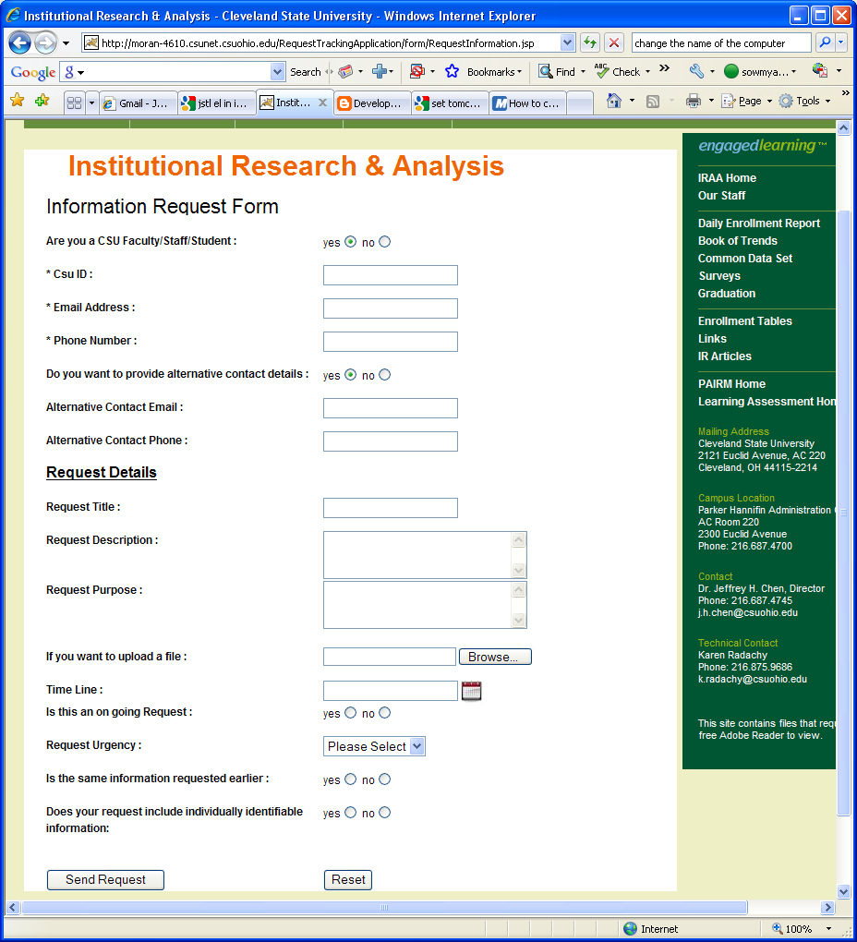

Appendix 2. Information Request Template

If Requestor is Not a CSU Faculty/Staff/Student:

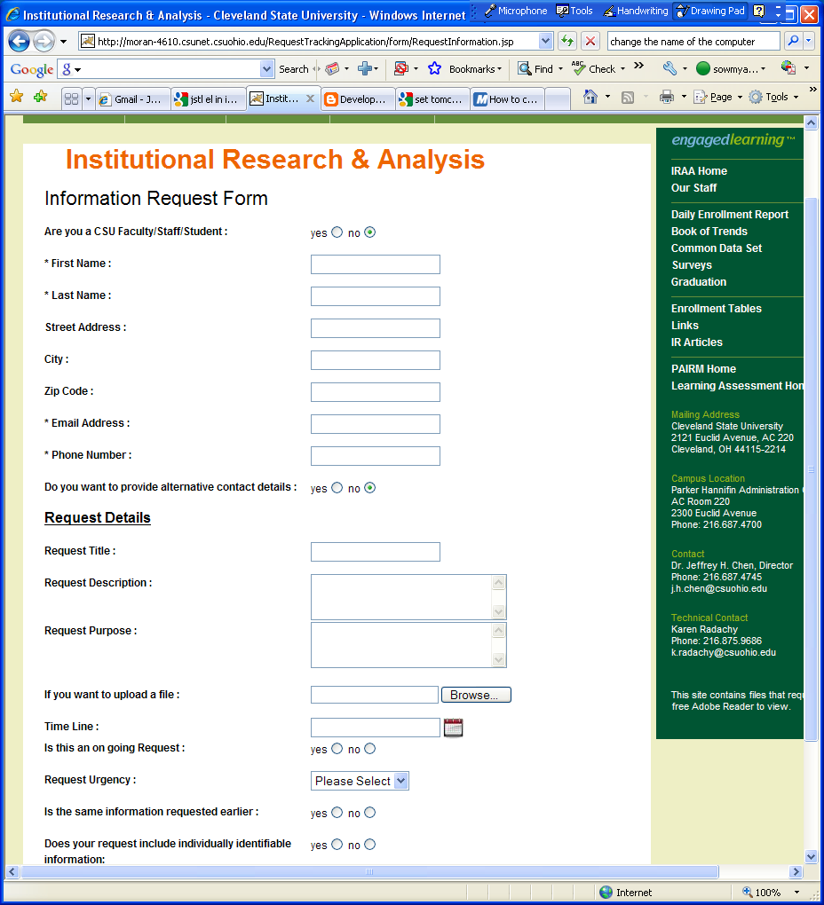

Appendix 2. Information Request Template

Request Assignment Form (Internal)

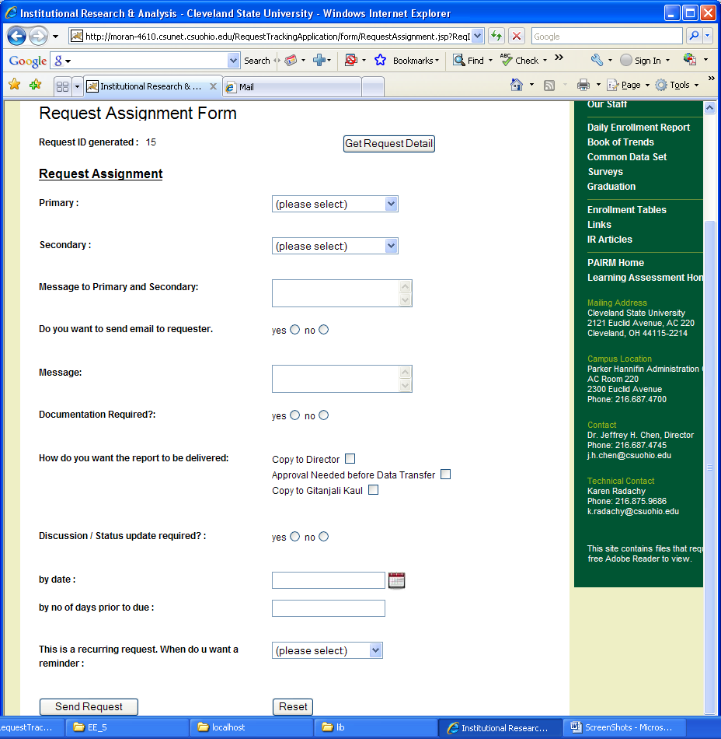

Appendix 2. Information Request Template

Status Update Form (Internal)

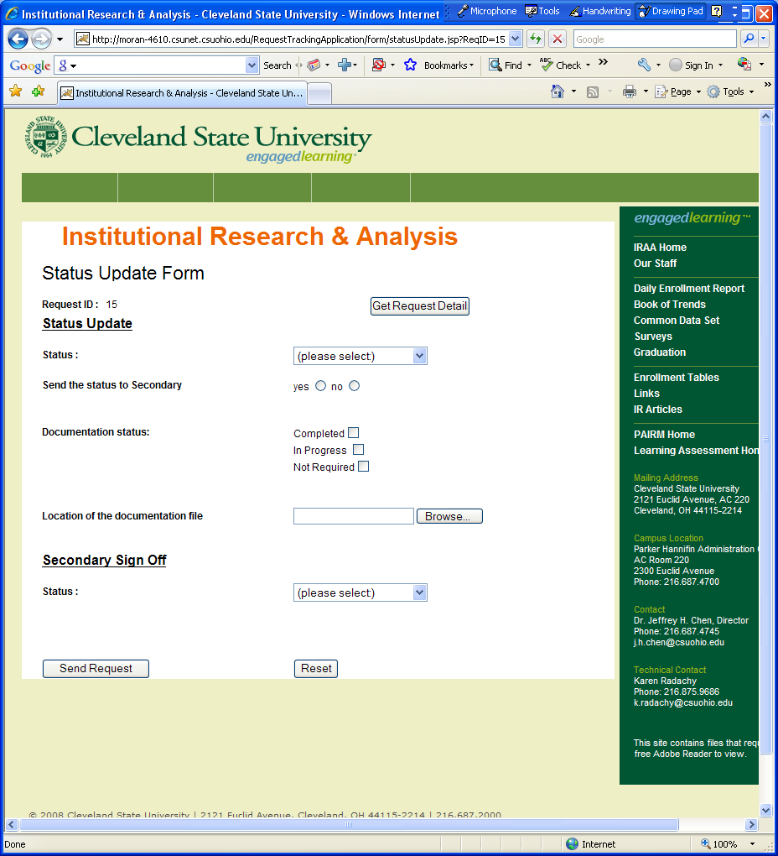

Appendix 3. IRAA Project Documentation Template

Documentation/Procedures

Project: Name of the Project/Request

By: Who created the project/request

Date: Date the project/request was created.

Description: Describe what the project/request is.

Include

Name of Requestor:

Due Date of Project/Request:

Details of the Project or Request:

Anything else that might be considered important information:

Procedures: Describe what was done in order to complete the project/request and
what would need to be done in order to run the process again if requested again.

Include
Name of the database and where is it located if Access
Steps that actually run the process
Any tables that are used
Any other information that might be considered important.

Suggestions for Improvement and Action(s) Taken: Note any suggestions or steps that could improve the project in the future. Also document the actions taken to facilitate or implement the improvement (e.g., contacting a data custodian to notify him or her of missing data, changing a particular step in the procedures, etc.)

Outcome: when the request was completed and provided to the requestor (and in what format, e.g., email, hard copy, secured folder on lanyard)

Appendix 4. Association of Institutional Research (AIR) Code of Ethics
Adopted by AIR membership 12/18/92
Updates Approved by the AIR Board 12/14/01
PREAMBLE
The Code of Ethics of the Association for Institutional Research was developed to provide members of the Association with some broad ethical statements with which to guide their professional lives and to identify relevant considerations when ethical uncertainties arise. It also provides a means for individuals new to the profession to learn about the ethical principles and standards that should guide the work of institutional researchers.
Although the Association also serves those institutions that employ our members, our primary service to those institutions is achieved through our individual members. Hence this Code is directed to individuals and not institutions, although basic tenets contained within the Code are also applicable to our colleges and universities and should be compatible with institutional codes and values.
The persons who practice institutional research (IR) are a diverse group from many different academic backgrounds and from many different professional experiences. Add to this diversity among IR practitioners the tremendous variation in the practice of IR as defined at individual colleges and universities, and IR professionals would seem to have little common ground. It is precisely for these reasons that this Code of Ethics is important.
Many of the professions from which IR practitioners come have their own standards or codes for acceptable and even expected performance. This Code adds to those existing documents in recognition of the special and different demands inherent in the practice of institutional research. In many institutions the institutional researcher is viewed as the “guardian of truth” or the “conscience” of the institution. This is an extra burden for institutional researchers, and this Code provides some guidance to practitioners who bear that burden. Along with the other professional standards, this Code defines a normative expectation for institutional researchers in their work. At the same time, the Code provides the foundation for institutional research as a profession.
The application of this Code requires good judgment and common sense, and its use in any given case may depend upon the presence or absence of shared values, institutional politics, the individuals involved, and the level of the potential threat posed by a specific ethical lapse. There is no licensure process within institutional research, there is no court to determine guilt, and there are few absolutes. Thus the shades of gray highlighted in this Code need to be reviewed and applied carefully lest they be seen either as powerless or as all-powerful, neither of which is appropriate.
Although it provides standards, the Code does not provide a set of rules. Reasonable differences of opinion can and do exist with respect to interpretation, and specific application must take into account the context of a given behavior. A code of ethics cannot guarantee ethical behavior or resolve all disputes. Rather it merely sets forth standards to which professionals aspire and against which their actions can be judged (both by themselves and others). Ethical behavior should result from a personal commitment to engage in ethical practice and an attempt to act always in a manner that assures integrity. All members of AIR should pledge to maintain their own competence by continually evaluating their research for scientific accuracy, by conducting themselves in accord with the ethical standards expressed in this Code, and by remembering that their ultimate goal is to contribute positively to the field of postsecondary education.
Finally, this Code is a living document that must change and be shaped as the practice of institutional research continues to evolve and develop.
Thanks and acknowledgement to the American Statistical Association, the National Association of Professional Geriatric Care Managers, the National Association of Social Workers and to the members of the Association for Institutional Research who commented on and contributed to this revision of the Code
SECTION I - COMPETENCE
I (a) Claims of Competence. The institutional researcher shall not, in job application, resume, or the ordinary conduct of affairs, claim or imply a degree of competency he/she does not possess.
I (b) Acceptance of Assignments. The institutional researcher shall not accept assignments requiring competencies he/she does not have and for which he/she cannot effectively rely upon the assistance of colleagues, unless the supervisor has been adequately apprised or unless he/she would acquire the necessary competence prior to doing the research. Institutional researchers should use methodologies or techniques that are new to them only after appropriate study, training, consultation, and supervision from people who are competent in those methodologies or techniques.
I (c) Training of Subordinates. The institutional researcher shall provide subordinates with opportunities for professional growth and development.
I (d) Professional Continuing Education. The institutional researcher has the responsibility to develop his/her own professional skills, knowledge, and performance and to keep abreast of changes in the field.
SECTION II - PRACTICE
II (a) Objectivity.
i) Unbiased Attitude. The institutional researcher shall approach all assignments with an unbiased attitude and strive to gather evidence fairly and accurately.
ii) Conflicts of Interest. The institutional researcher should be particularly sensitive to avoid personal conflicts of interest when performing services.
II (b) Use of Accepted Technical Standards. The institutional researcher shall conduct all tasks in accordance with accepted technical standards.
II (c) Initial Discussions. Before an assignment is begun, the institutional researcher shall clarify with the sponsor and/or major users the purposes, expectations, strategies, and limitations of the research.
i) Special care shall be taken to recommend research techniques and designs that are appropriate to the purposes of the project.
ii) Special care shall be taken to advise the sponsor and/or major users, both at the design phase and, should the occasion arise, at any time during the execution of the project, if there is reason to believe that the strategy under consideration is likely to fail or to yield substantially unreliable results.
II (d) Identification of Responsibility. The institutional researcher shall accept responsibility for the competent execution of all assignments which he/she, or a subordinate, undertakes, and shall display individual and/or office authorship, as appropriate, on all such reports.
II (e) Quality of Secondary Data. The institutional researcher shall exercise reasonable care to ensure the accuracy of data gathered by other individuals, groups, offices, or agencies on which he/she relies, and shall document the sources and quality of such data.
II (f) Reports. The institutional researcher shall ensure that all reports of projects are complete; are clearly written in language understandable to decision-makers; fully distinguish among assumptions, speculations, findings, and judgments; employ appropriate statistics and graphics; adequately describe the limitations of the project, of the analytical method, and of the findings; and follow scholarly norms in the attribution of ideas, methods, and expression and in the sources of data.
II (g) Documentation. The institutional researcher shall document the sources of information and the process of analysis in each task in sufficient detail to enable a technically qualified colleague to understand what was done and to verify that the work meets all appropriate standards and expectations.
SECTION III - CONFIDENTIALITY
III (a) Atmosphere of Confidentiality. The institutional researcher shall establish clear guidelines about confidentiality issues within the institutional research office.
III (b) Storage and Security. The institutional researcher shall organize, store, maintain, analyze, transfer and/or dispose of data under his/her control in such a manner as to reasonably prevent loss, unauthorized access, or divulgence of confidential information.
III (c) Release of Confidential Information. The institutional researcher shall permit no release of information about individual persons that has been guaranteed as confidential, to any person inside or outside the institution except in those circumstances in which not to do so would result in clear danger to the subject of the confidential material or to others; or unless directed by competent authority in conformity with a decree of a court of law.
III (d) Special Standards for Data Collection.
i) Balancing Privacy Risks Against Benefits. The institutional researcher shall, at the design stage of any project, thoroughly explore the degree of invasion of privacy and the risks of breach of confidentiality that are involved in the project, weigh them against potential benefits, and make therefrom a recommendation as to whether the project should be executed, and under what conditions.
ii) Developing Specific Guidelines. Where appropriate, the institutional researcher shall adopt a written description of any specific steps beyond the regular guidelines within the institutional research office that are necessary during a specific assignment to ensure the protection of aspects of privacy and confidentiality that may be at specific risk.
iii) Disclosure of Rights. The institutional researcher shall ensure that all subjects are informed of their right of refusal and of the degree of confidentiality with which the material that they provide will be handled, including where appropriate, the implications of any freedom of information statute. Any limits to confidentiality should be made clear.
iv) Apprisal of Implications. The institutional researcher shall apprise institutional authorities of the implications and potentially binding obligations of any promise to respondents regarding confidentiality and shall obtain consent from such authorities where necessary.
SECTION IV - RELATIONSHIPS TO THE COMMUNITY
IV (a) Equal Treatment. The institutional researcher shall promote equal access and opportunity regarding employment, services, and other activities of his/her office, without regard to race, creed, gender, national origin, disability or other accidental quality; and in analysis, demeanor, and expression shall be alert to the sensitivities of groups and individuals.
IV (b) Development of Local Codes of Ethics. The institutional researcher should develop and promulgate a code of ethics specific to the mission and tasks of the institutional research office and should strive to cooperate with fellow practitioners in the institution in developing an institution-wide code of ethics governing activities in common. The institutional researcher should take reasonable steps to ensure that his/her employers are aware of ethical obligations as set forth in the AIR Code of Ethics and of the implications of those obligations for work practice.
IV (c) Custody and Archiving. The institutional researcher shall apply all reasonable means to prevent irrevocable loss of data and documentation during its immediately useful life; and, being aware of the role of data as institutional historic resource, shall act as an advocate for its documentation and systematic permanent archiving.
IV (d) Assessment of Institutional Research. The institutional researcher shall develop and implement regular assessment tools for the evaluation of institutional research services.
IV (e) Institutional Confidentiality. The institutional researcher shall maintain in strict confidence and security all information in his/her possession about the institution or any of its constituent parts which by institutional policy is considered to be confidential, and shall pursue from Section III of this Code all processes for that purpose as are appropriate.
IV (f) Integrity of Reports. The institutional researcher shall make efforts to anticipate and prevent misunderstandings and misuse of reports within the institution by careful presentation and documentation in original reports, and by diligent follow-up contact with institutional users of those reports. If an institutional research report has been altered, intentionally or inadvertently, to the degree that its meaning has been substantially distorted, the institutional researcher shall make reasonable attempts to correct such distortions and/or to insist that institutional research authorship be removed from the product.
IV (g) External Reporting. The institutional researcher has an obligation to the broader community to submit and/or report accurate data and professionally responsible interpretive material when requested by legitimate authority, including federal, state, and other governmental agencies and accrediting bodies. With respect to private inquiries, such as those from guidebook editors, journalists, or private individuals, the institutional researcher, should he/she respond, is bound by the same standards of accuracy, confidentiality, and professionally responsible interpretation.
SECTION V - RELATIONSHIPS TO THE CRAFT
V (a) Research Responsibilities.
i) The institutional researcher shall seek opportunities to contribute to and participate in research on issues directly related to the craft and in other professional activities, and shall encourage and support other colleagues in such endeavors.
ii) Acknowledging Credit. Institutional researchers should take responsibility and credit, including authorship credit, only for work they have actually performed and to which they have contributed. They should honestly acknowledge the work of and the contributions made by others.
V (b) Integrity of the Profession. The institutional researcher should work toward the maintenance and promotion of high standards of practice.
i) Institutional researchers should uphold and advance the values, ethics, knowledge, and mission of the profession. They should protect, enhance, and improve the integrity of the profession through appropriate study and research, active discussion, and responsible criticism of the profession.
ii) Institutional researchers should contribute to the knowledge base and share with colleagues their knowledge related to practice, research, and ethics. They should seek to contribute to the profession’s literature and to share their knowledge at professional meetings and conferences.
V (c) False Accusations. Institutional researchers shall take care not to falsely demean the reputation or unjustly or unfairly criticize the work of other institutional researchers.
V (d) Incompetence of Colleagues. Institutional researchers who have direct knowledge of a colleague’s incompetence should consult with that colleague when feasible and assist the colleague in taking remedial action.
V (e) Unethical Conduct of Colleagues.
i) The institutional researcher shall take appropriate measures to discourage, prevent, identify, and correct unethical conduct of colleagues when their behavior is unwittingly or deliberately in violation of this code or of good general practice in institutional research.
ii) Institutional researchers who believe that a colleague has acted unethically should seek resolution by discussing their concerns with the colleague when feasible and when such a discussion is likely to be productive.

